**Program Description**

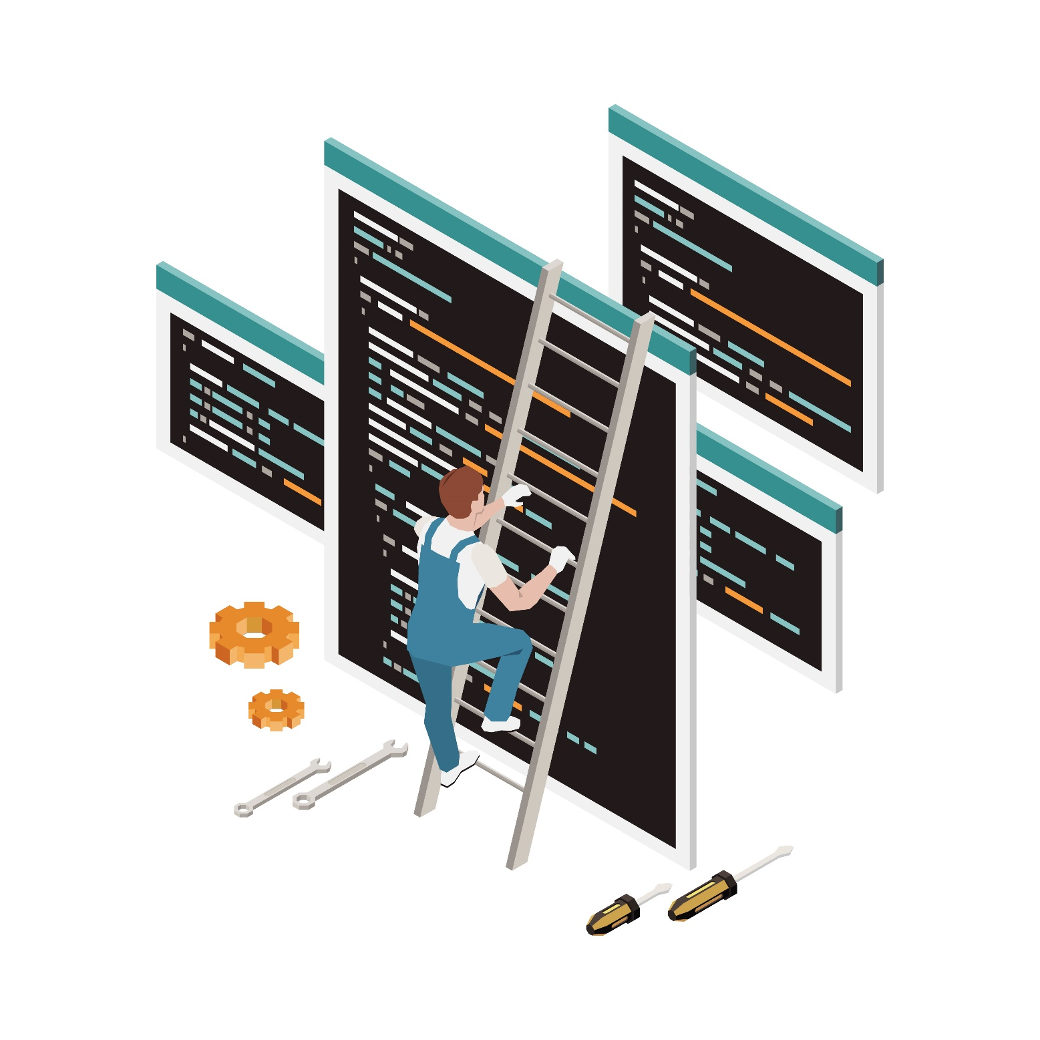

a) Software and hardware tools you used:

Software used: we used Windows 11, Eclipse as an IDE

Hardware used: our personal laptops from MSI & HP & huawei with i5 8th gen and ryzen5 4500u.

b) How did you divide your project to subtasks and how they interact with each other?

We divide it into 3 mean parts with the main:

1. **Reading thread**: reads the file and fills the job queue and the list of the processes.

2. **Transporting thread**: transporting the PCB's from job queue to ready queue.

3. **Processing Threads**: Takes processes from the ready queue and execute it.

With helping classes and Enums.

c) Strength and weakness of your program

**Strength**: there is no race condition, easy to read and modify.

**Weakness**: we are moving the processes from the job to the ready queues based on the order, not the memory available.